Use-Case Realization Report (Requirements)
Request For Certificate

Issue 1.0
Revision History
Date | Issue | Description | Author

Table of Contents
1. Brief Description 4
2. Flow of Events 4
2.1 Standard Flow 4
2.2 Exceptions 4
3. Interaction Diagrams 4
3.1 Domain Collaboration Diagram: Propose New Project 4
4. Participating Objects 4
5. Derived Requirements 4

Use-Case Realization Report
Request for Certificate

Brief Description
The use case enables registered user to propose new project.

Flow of Events
The standard flow of events for this use case and any exceptions are described in the following subsections. See section 3.1 for an overview of the participating Actors and Domain Objects.

Standard Flow

Precondition: User has logged in the system

This use case provides the user interface related functionality that will be provided to the User, as follows:
- The User clicks ‘Request For Certificate’ link and the system is redirected to ProjectDetailsScreen.
- The system will check whether user is qualified to get the certificate
- After validation, the system will display the ‘Certificate Request has been sent for manager Review’ in a pop-up window.
- The System shall also send the notification email to all the people with System admin role.

Exceptions
The following exceptions have been identified:

Interaction Diagrams

Domain Collaboration Diagram: Propose New Project
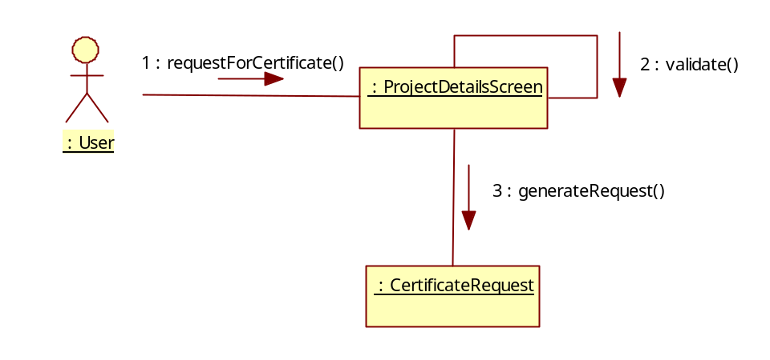

Participating Objects
:

Derived Requirements

